Asset list

Learning aim A: 2A.P2
Evidence collection 1
Name of website: tobisalawu.wordpress.com
Learner name: Tobi Salawu
No. | Page | Description / how will this asset enhance the web site | Type  (graphic, audio, Video etc.) | Source
1. | LEVEL 2 IT WORK | An image describing the topics covered in unit 1 |  | hhttps://tobilobasalawu.github.io/digitalportfolio/image/unit1.jpg
2. | Home | An image of myself on the get know me section on the about page | image | blob:https://teams.microsoft.com/dd6ea8d9-4da4-4e87-ac0c-d3d1825f1b38
3. | LEVEL 2 IT WORK | An image displays a laptop filled with lines of code. |  | https://tobilobasalawu.github.io/digitalportfolio/image/unit12.png
4. | LEVEL 2 IT WORK | An image of a spreadsheet record | 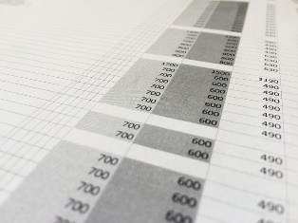 | https://pixabay.com/photos/search/spreadsheet/
5. | LEVEL 2 IT WORK | An image of 0’s and 1’s with computers and people at the background that represents databases |  | https://cdn.pixabay.com/photo/2017/10/29/14/48/data-2899902_640.jpg
6 | LEVEL 2 IT WORK | Ab image of an Ethernet cable connected to a router.  The image represents a computer network | 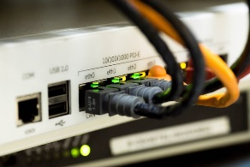 | https://pixabay.com/photos/network-cable-ethernet-1572617/
7 | LEVEL 2 IT WORK | An image that shows how a website works into different categories |  | https://cdn.pixabay.com/photo/2018/01/26/09/07/hand-3108158_640.jpg
8. | All Pages | A logo of GitHub which will be used for the hyperlink. |  | https://www.flaticon.com/free-icon/github_2111432?term=github&page=1&position=4&origin=search&related_id=2111432
9. | All Pages | A logo of LinkedIn which will be used for the hyperlink. |  | https://www.flaticon.com/free-icon/linkedin_3669739?term=linked+in&page=1&position=8&origin=search&related_id=3669739
10 | About | A logo for python on the about page of the website |  | https://www.flaticon.com/free-icon/python_5968350?term=python&page=1&position=5&origin=search&related_id=5968350
11 | About | A logo for CSS on the about page of the website |  | https://www.flaticon.com/free-icon/css-3_732190?term=css&page=1&position=1&origin=search&related_id=732190
12 | About | A logo for HTML on the about page of the website |  | https://www.flaticon.com/free-icon/html_1051277?term=html&page=1&position=1&origin=search&related_id=1051277
13 | About | A logo for JAVASCRIPT on the about page of the website |  | https://www.flaticon.com/free-icon/js_5968292?term=js&page=1&position=2&origin=search&related_id=5968292
14 | LEVEL 2 IT WORK | An image showing a computer’s hardware and software’s. |  | https://tobilobasalawu.github.io/digitalportfolio/image/unit2.png
15. | LEVEL 2 IT WORK | An image describing a digital portfolio and it’s component |  | https://tobilobasalawu.github.io/digitalportfolio/image/unit3.jpeg
16 | All pages | A logo of my name |  | https://tobilobasalawu.github.io/digitalportfolio

